**Touch**

**Typing**

**Class Five**

**Lab 10**

|  |
| --- |
| Lab Objectives:  * Introducing Letters: W  S   L  O  Y |

# Finger Placement

## With the addition of these five new letters, you're really going to go places.

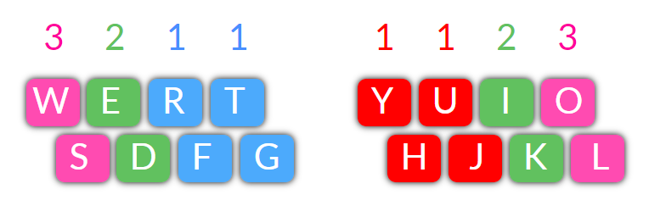

## W and S on the LEFT hand.  Y, L and O on the RIGHT hand.

## Heres's some of the longest words you can now make with the letters you'll be typing from the chart above:

## *Flourished, Righteously, Worthiest, Fortitude and Yourself*.... plus a heap of common every day words like:

## *yes, right, like, trust, give, follow, look, rest, joke, high, just, food.*

# Exercises - 1​​

## Left Hand Drills - focus letters S and W

## Use your LEFT HAND (ring) FINGER No. 3 for W and S.

## fff ddd sss www fff ddd sss www fff ddd sss www

## fds fds fdsw fdsw frf ded sws frf ded sws frf ded sws

## fdd fss ree rww rww rew rew rews rews dew dews

## ffds ffds ffdsw fdsw fds fdsw wsdf wsdf sdf fdsdf fdsdf

# Exercises -  2

## Right Hand Drills - focus letters Y, L and O

## Use your RIGHT HAND FINGER No. 3 for the letters L and O.

## Use your RIGHT HAND INDEX FINGER No. 1 for Y (stretch the H finger to Y).

## juj juj jujyj jujyj jyj jhj jhj jhjyj jhjyj jujhj jujhj ujh ujh

## jklol jklol jklol lol lol lol lol jujhj klol jujhj klol kol kol

## -

# Exercises - 3

### Left Hand Only - Focus on letters S and W

## sweet sweets sweeter swede tweed tweet tweets tweeted street streets

## ewe ewes sew sews resew sewed stew stewed strew strewed grew

## few fewer fewest free frees freer fret fretted fest fester test tester

## we wee were wet wets west wrest rests wed rewed weed weeds

-

# Exercises - 4

### Right Hand Only - Focus on letters L, O and Y

## 

## lo lo oh oh yo yo oi oil oily hoy yuk you ilk joy yolk killjoy kook kooky

## lull hull hulk hulky loo look hoy holy holly jolly lolly hook hooky hullo

## ill ill kill kill hill jill jill jill ilk ilk ilk oil oily joy joy lily lily jokily jokily

-

# Exercises - 5

### Both Hands - Focusing on all new letters: S, W, L, O and Y

## juj jyyj joy toy roy try fry juj jyyj joy toy roy try fry juj jyyj joy toy roy try fry fly why

## soy soil silly soul souls well wells yell yells swell swells wile wily while sty stye style stole

## wet wets jet jets jest jester yes let lets letters wet wets jet jets jest jester yes let lets letters

# Exercises - 6

### Both Hands

## hole whole while whist whistle when trolley trill thrill

## rolls tolls folds holds shoulders sisters swifter sword

## full fuller drill driller toll tolls roll rolls folders holdersy

# Try These Fun Phrases

## eighty joyful judges foiled the witty jokers with two wise words;

## this is why sly joy wilson just took the first july flight out;

## yes tough wily willis fought foolishly to destroy freddy kelly;

## 